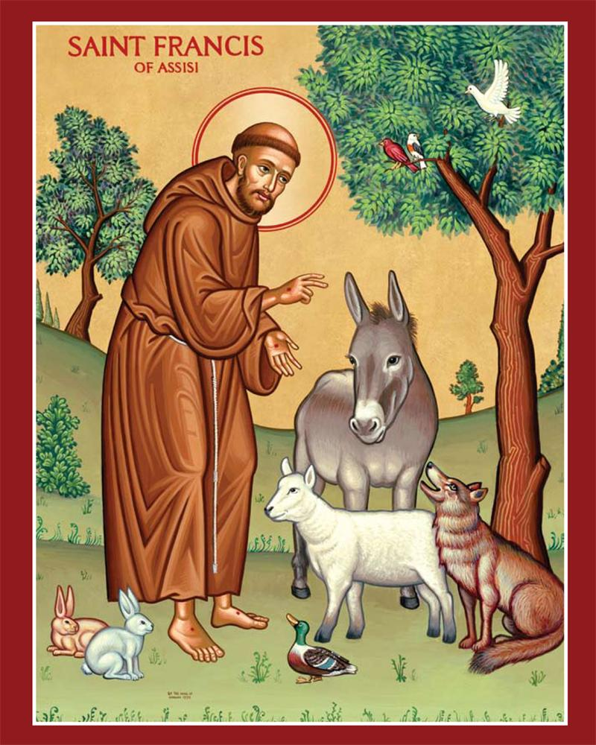
October 2026 marks the 800th Anniversary
of the death of Saint Francis of Assisi.

Our Mother of Sorrows Parish has been given permission by Bishop Persico to have a Mass in honor or Saint Francis of Assisi
on Sunday, October 25, 2026.

Special plans will be made and those attending will receive a plenary indulgence.

Refreshments will follow in
Saint Casimir’s Social Hall.

All are welcome and invited to attend.
MARK YOUR CALENDARS…
Sunday, October 25, 2026
11:00AM Mass
Saint Casimir’s Church
630 Hess Ave., Erie, PA 16503

